Week 2 (Group meeting)

Meeting Date: 24/1

Meeting mins: 97mins

Meeting members: Jacko, Xu Cheng, Xueting

Meeting Content:

1. Setting the basic flow chart for the modeling part, the draft like below: (Brain Storm)

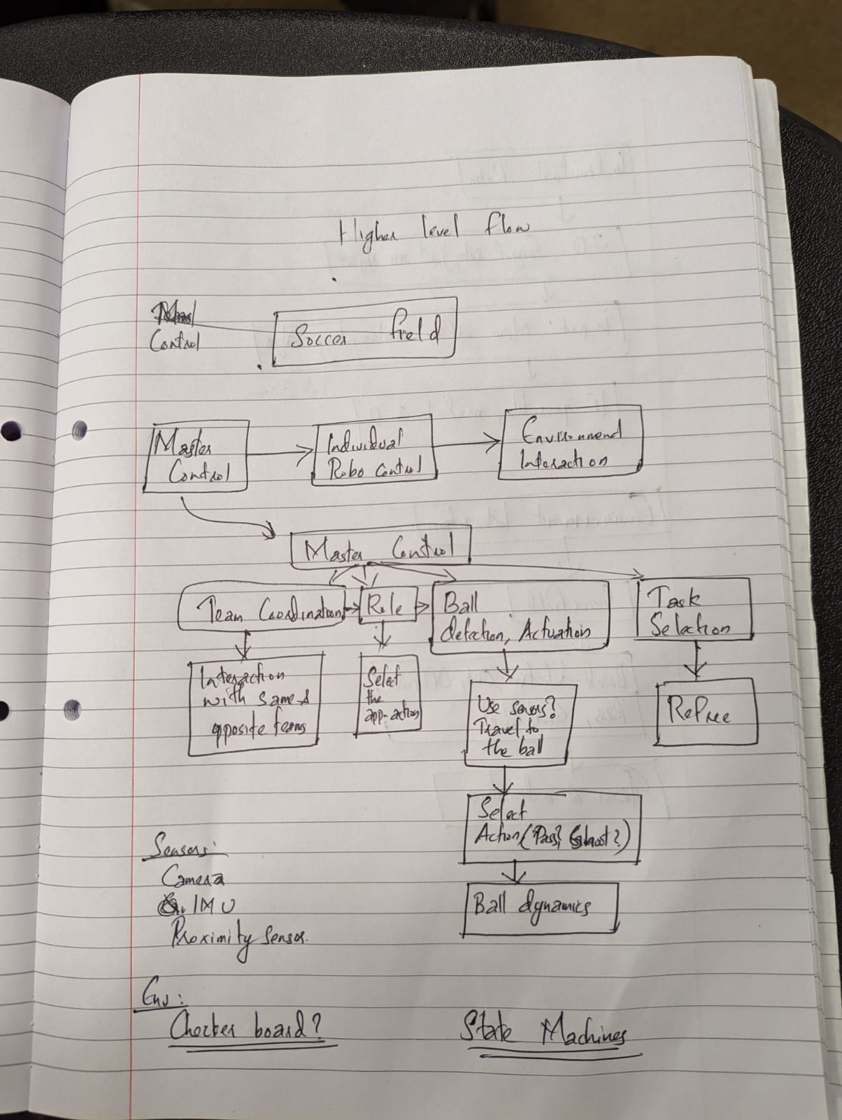

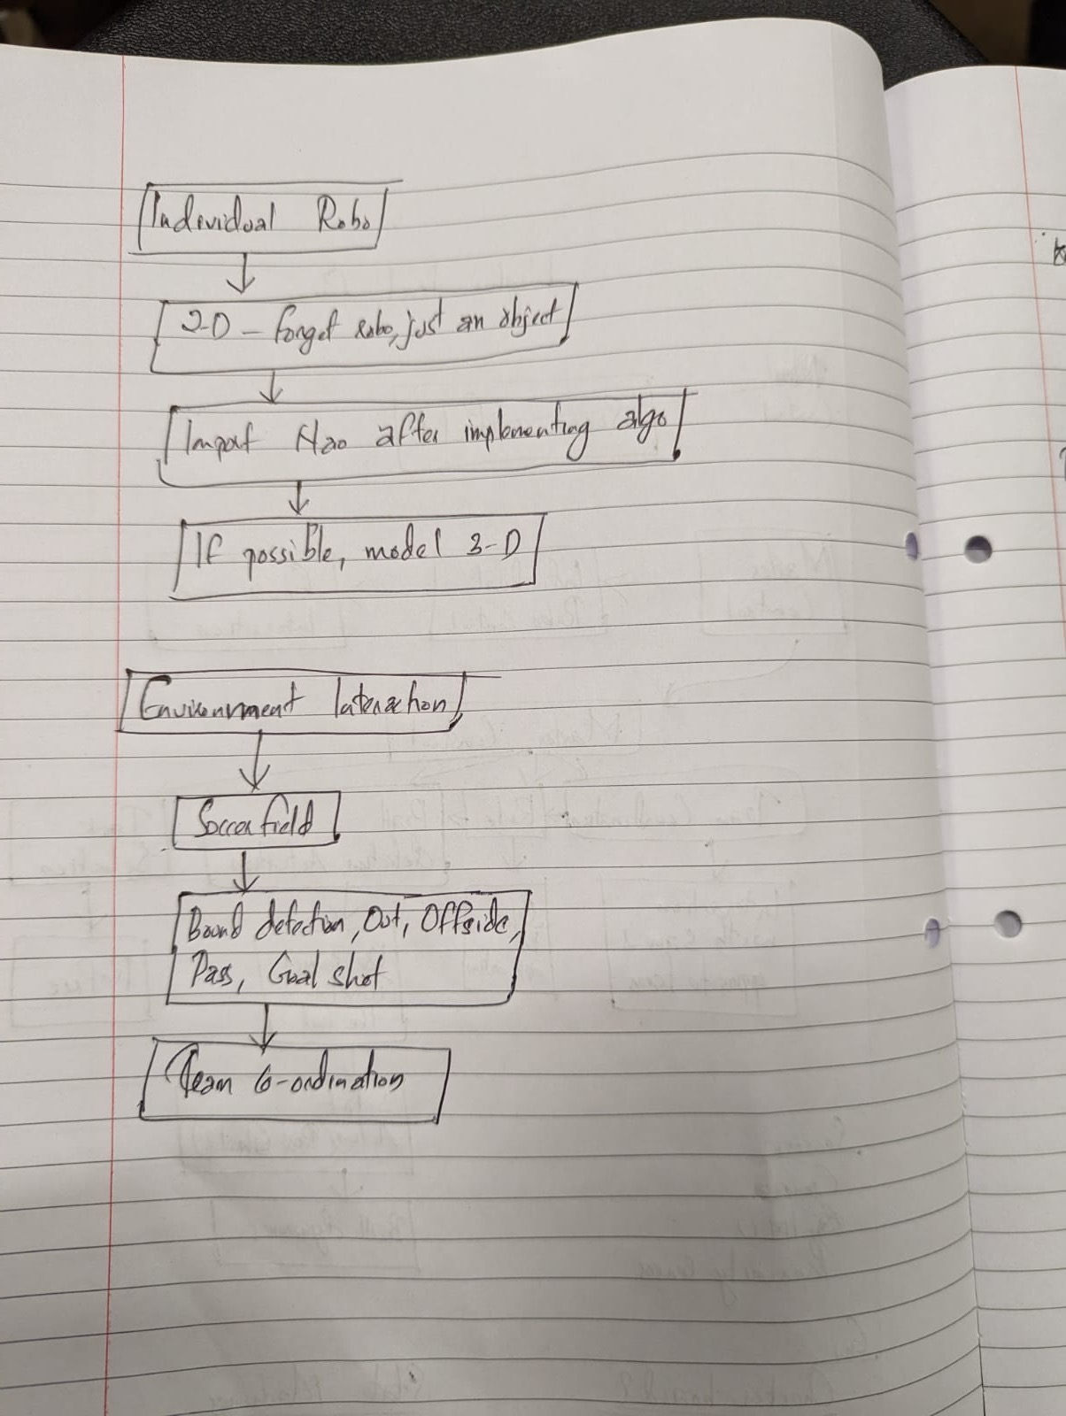

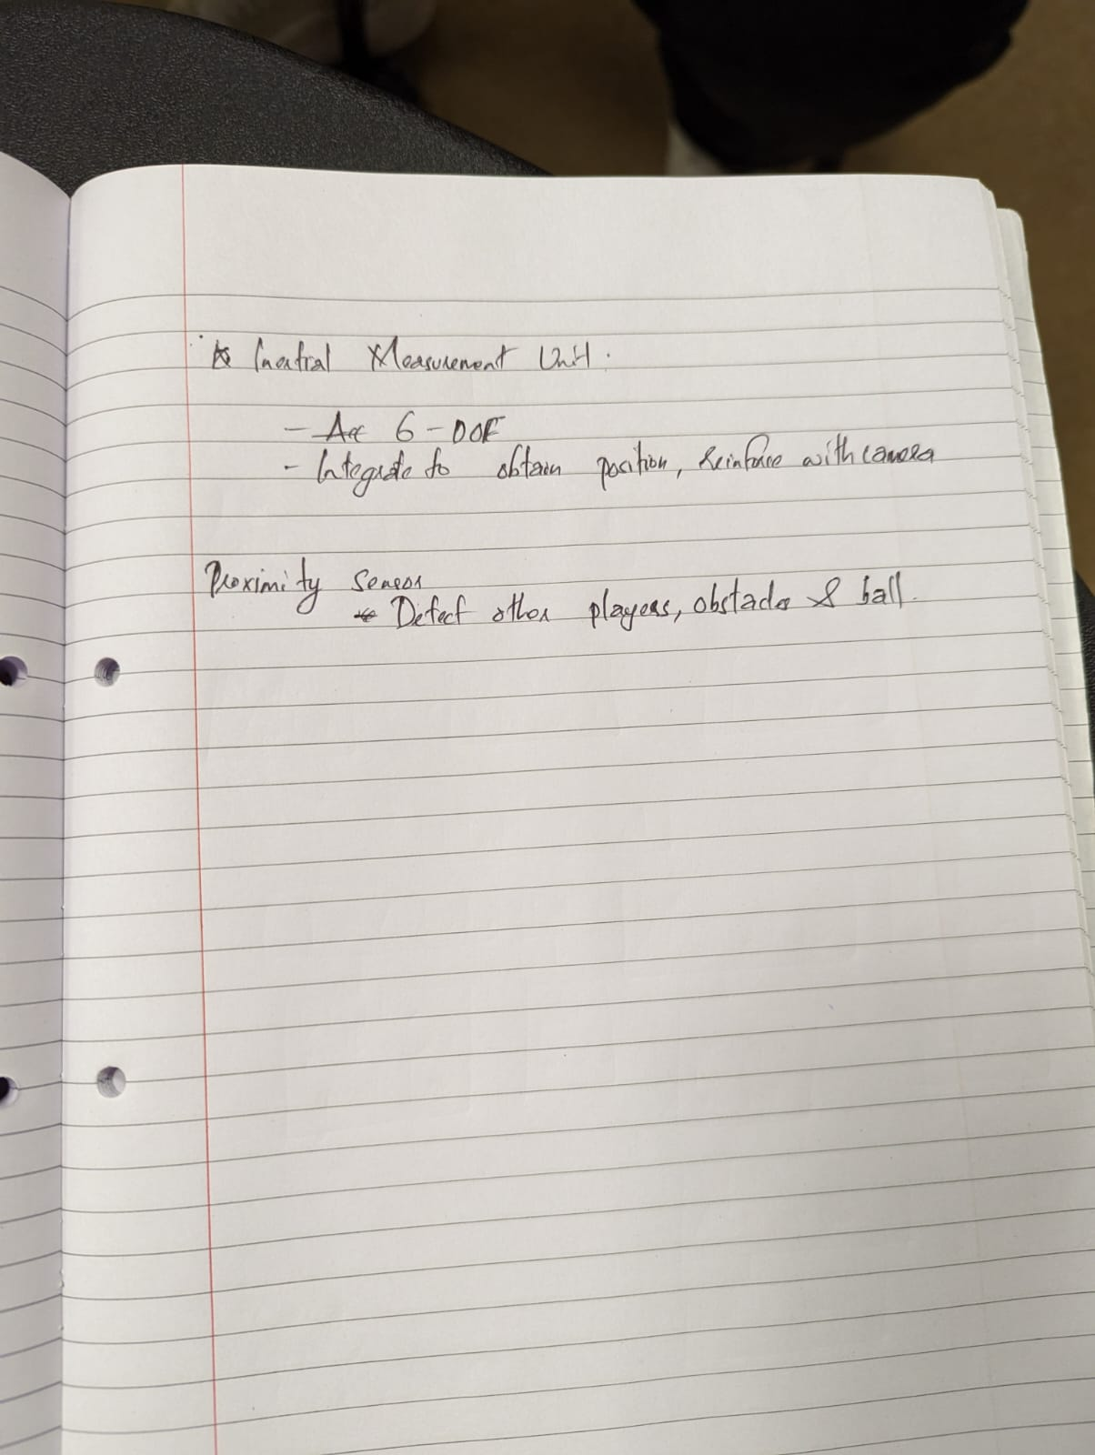

1. Flow chart for the coding part, shows that: (Brainstorm)

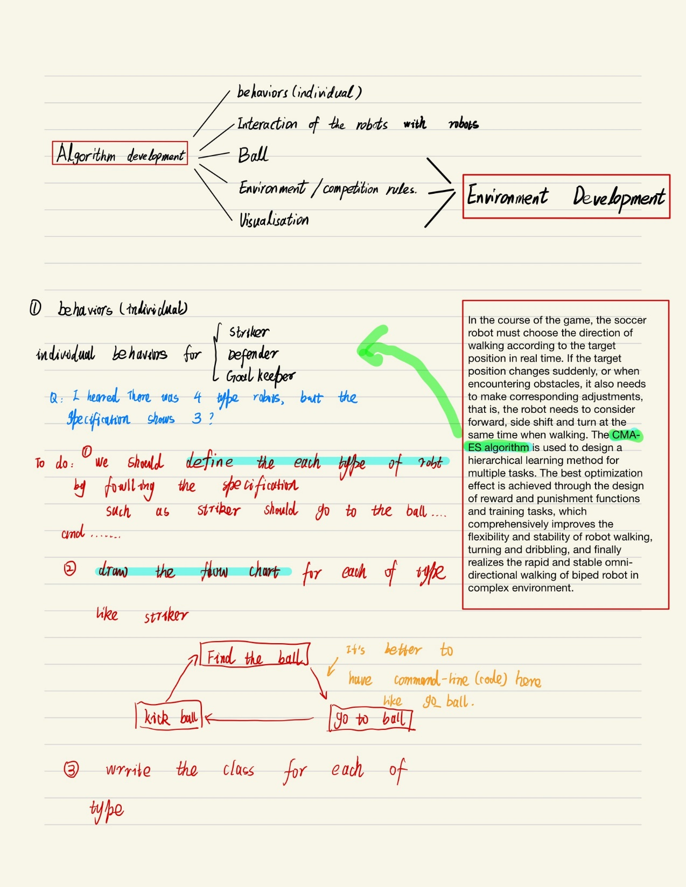

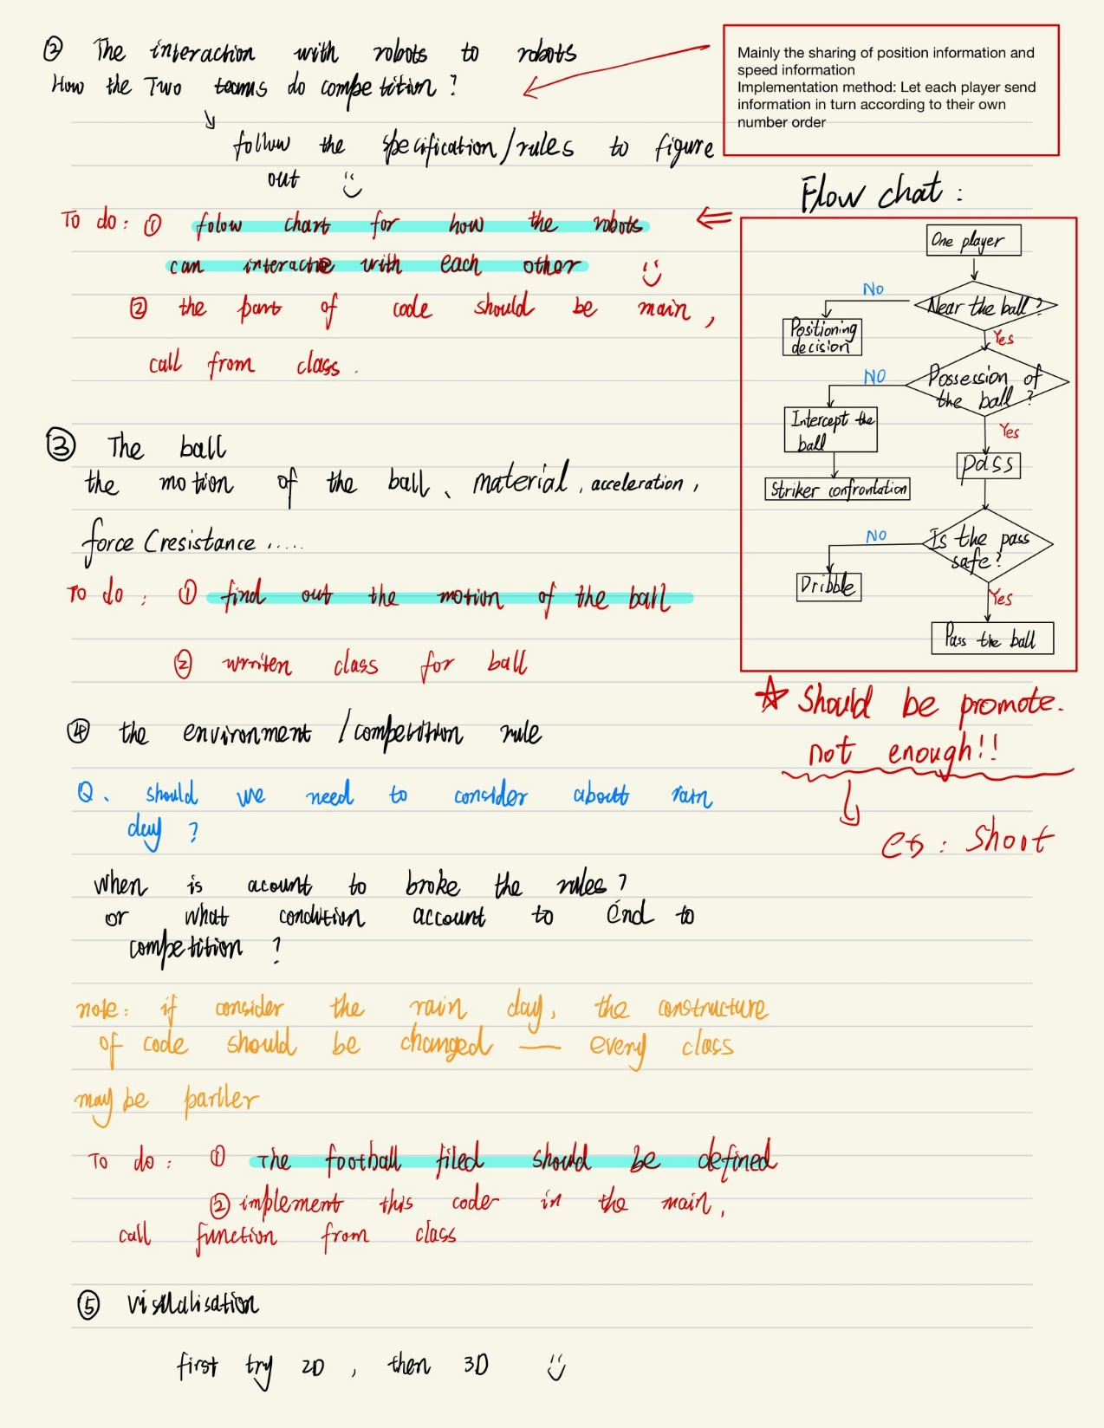

To-Do List

1. Need to divide the work the in next meeting.
2. Ppt also needs to be prepared for the next meeting with the supervisor.
3. Updated the Gant chart.